✴

**Template**

**Build empathy**

The information you add here should be representative of the observations and research you've done about your users.

Empathy map

Use this framework to develop a deep, shared understanding and empathy for other people. An empathy map helps describe the aspects of a user's experience, needs and pain points, to quickly understand your users’ experience and mindset.

# Says

What have we heard them say? What can we magine them saying?

# Thinks

What are their wants, needs, hopes, and dreams? What other thoughts might influence their behavior?

Give them a name and a portrait to empathize with your persona.



many more knowledge is help to get a job easly

get a job for a financial freedom

if you have a certificate about your knowledge then it will be easily get a job

complete the course give the knowledge to get a job

i watch your advertisement from youtube then i come here

they start as a junior worker to get a experience

make a mini project with team is make best team

they use a mail i start watching a

to contact youtube chennel

a surrounding to solve my

to share about problem and get

our work knowledge about my job

they talk about project work and personal thing with their colleagues

**Empathy Map**

they must have additude as a team guy and like to learn a new think

they eaten snakes and play some games in a break time

if they have favourite work to do then day will be a good day

share the little bit amount about your knowledge is help to make a best socialism

they expect high speed network natural environmental best canteen

try to crack a many more interviews is help to get a dream job

# [Share template feedback](https://muralco.typeform.com/to/CiqaHVat?typeform-source=app.mural.co)

**Does**

What behavior have we observed? What can we imagine them doing?

# Feels

What are their fears, frustrations, and anxieties? What other feelings might

influence their behavior?

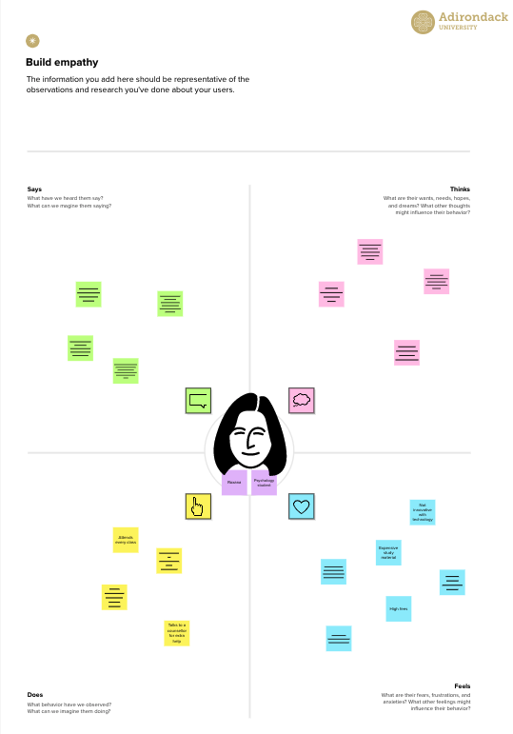

**Need some inspiration?**

See a finished version of this template to kickstart your work.

[**Open example**](https://app.mural.co/template/f44b7843-7c23-408c-bd36-7b0c9409dc20/96efd10c-81d2-401e-8072-4e87935e5d6b)